Full name ________________ Group ________________

Practice to Lecture 4 Descriptions

Task 1

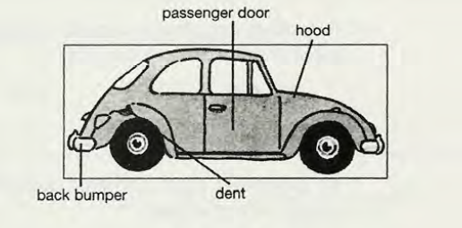
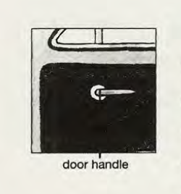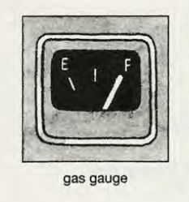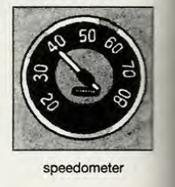

My First Car

My first car was old and ugly but I loved it anyway. Its main paint color was black, but it also had blue, green, yellow, and white paint in different places. The body was in terrible condition. It had several big dents. The lock on the hood was broken, so I had to tie it down with a strong rope. Also, the back bumper was rusty, and the front window was cracked. The inside of the car was also in terrible condition. The passenger door handle was missing, so you couldn’t open the passenger door from the inside. The seats had at least ten large holes in them. Also, the gas gauge was broken. lt always showed “full,” so I often ran out of gas. The speedometer was broken too, so I never knew how fast I was driving. Like a first love, my old VW had a few faults, but in my mind it was perfect.

- Underline all the adjectives in the following paragraph.
- Which space order did the writer of this paragraph use?

top to bottom bottom to top
right to left left to right
far to near near to far
outside to inside inside to outside

- .

Task 2
Add the cumulative adjectives in parentheses to describe the underlined noun in each sentence. Add them in the correct order

- There were toys in the middle of the floor, (broken, several, plastic) - There were several broken plastic toys in the middle of the floor.

- Clouds announced an approaching rainstorm, (black, big) - ______

- Flags hung from every window, (colorful, rectangular) - ___________

- Children played on the grass, (green, thick) - ___________

- I dream about relaxing on a beach, (sand, white, beautiful) - __________

- They got married in a church, (stone, small, Italian) - ___________

- The parents left children with the grandparents while they worked, (young, their, two) - _________

- Class has thirty students, (advanced, Mr. Thompson’s, English) - ______

- The real estate agent pointed out problems with the house, (minor, several) - _________

- Windows were broken, (large, bedroom, four) - _______

Task 3
Add as many specific details as you can to these vague descriptions. Use present tense verbs in your sentences.

Example:
My uncle is large.
- He is six feet, three inches tall and weighs 250 pounds
- He wears size fifteen shoes.
- His shirts are XXX large.
- He can hold a basketball upside-down in one hand

- My boss has a nice house.
- Tom is a bad driver.
- The village is very small.
- The new game is interesting

